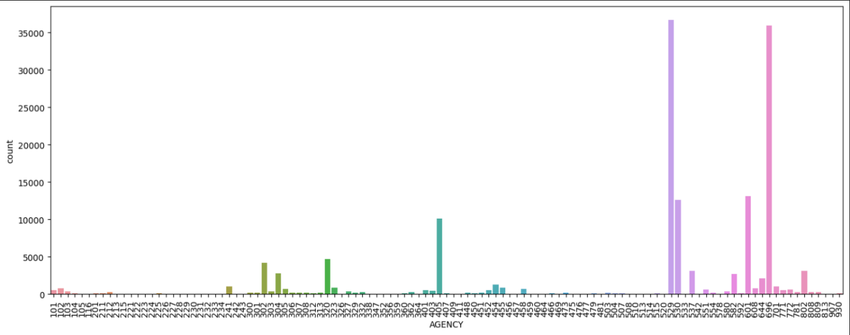

The count of entries varies significantly across different agencies.

A few agencies dominate the count, with two specific agencies having counts above 30,000, while most other agencies have considerably lower counts.

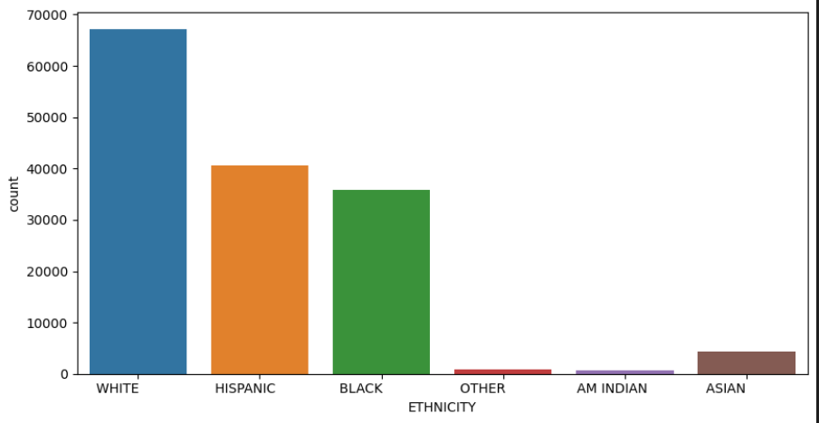

The majority of individuals belong to the "WHITE" ethnicity, followed by "HISPANIC" and "BLACK."

Ethnic groups such as "OTHER," "AM INDIAN," and "ASIAN" have considerably lower counts.

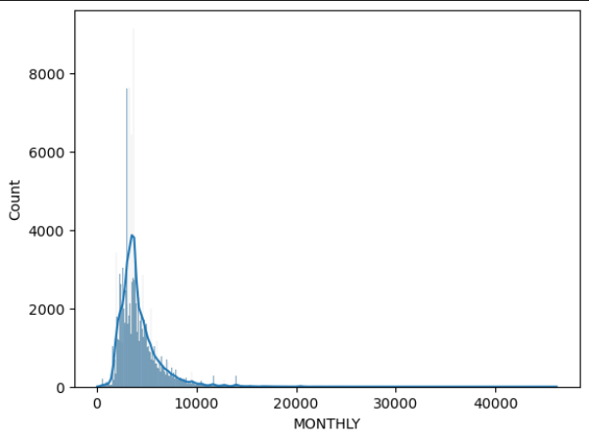

The distribution of the "MONTHLY" variable is highly right-skewed, indicating that most values are concentrated on the lower end, with a long tail stretching towards higher values.

The majority of the data points are below 10,000, and very few observations are present beyond 20,000.

This suggests that a large proportion of individuals or entities have relatively low monthly values, with only a small number having extremely high values.

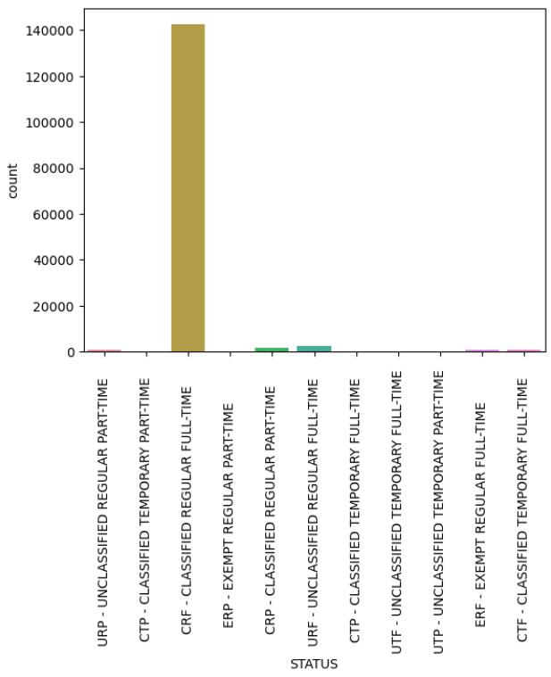

The graph shows a strong preference for classified, regular, full-time employment, dominating all other employment types. Part-time, temporary, and unclassified positions are minimally represented, indicating a focus on long-term, structured roles.

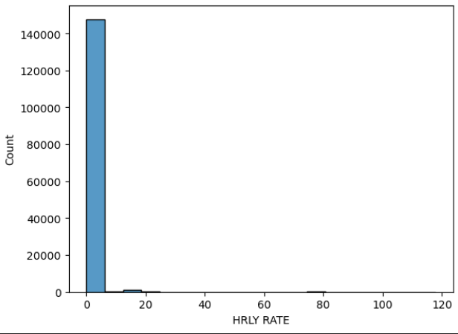

The histogram reveals a massive concentration of hourly rates at the low end, indicating limited variability and a strong skew towards lower pay or prices. Potential outliers exist at higher rates, but they are infrequent compared to the dominant low-rate cluster.